Understanding Execution Plans
Margarita Lovyannikova , Harry De Leon , Ted Forman , Qing Wang – Group 3
An execution plan is a set of steps used to access information of a SQL relational database management system. Since SQL is declarative, there are typically a large number of alternative ways to execute a given query, with widely varying performance. When a query is submitted to the database, the query optimizer evaluates some of the different plans for executing the query and returns what it considers the best alternative. Because query optimizers are imperfect, database users and administrators sometimes need to manually examine and tune the plans produced by the optimizer to get better performance.
When SQL Server executes a query, it will use an execution plan if one already exists. If there is no preexisting plan, SQL Server follows a series of steps to create a plan. Each plan is assigned a total cost for execution, and SQL Server uses the plan with the lowest costs.
- First, SQL Server checks if a trivial plan is available. If so, it will go ahead with this plan. For example, with an INSERT statement using the VALUES clause, there is only one possible execution.
- If no trivial plan is available, SQL will try to simplify the query, so that a trivial plan will be available. At this point SQL server will load any statistics that will help it in the cost-based process that follows. This cost-based process has three steps.
  - First is the transaction processing phase. In this phase, SQL Server picks out plans for simple queries typical of transaction processing databases.
  - If a cheap plan cannot be found, the Quick Plan phase starts. In this phase, SQL includes choices that are often useful in more complex queries.
  - The last phase is the Full Optimization Phase. In this phase, SQL Server compares every possible execution plan and then goes with the cheapest one.
Now let’s consider the following query: SELECT ProductName, Price FROM tblProduct WHERE ProdNum =1
How do we get the execution plan using ms sql studio express?
• From within the Query Analyzer is an option called "Show Execution Plan" (located on the Query drop-down menu). If you turn this option on, then whenever you run a query in Query Analyzer, you will get a query execution plan (in graphical format) displayed in a separate window.
• If you want to see an execution plan, but you don't want to run the query, you can choose the option "Display Estimated Execution Plan" (located on the Query drop-down menu). When you select this option, an execution plan (in graphical format) will immediately appear. The difference between these two (if any) is due to the fact that when a query is really run (not simulated, as in this option), current operations of the server are also considered. In most cases, plans created by either method will produce similar results.
You can also provide this information in text form using MISC: Execution Plan. From within the query analyzer: SET SHOWPLAN_TEXT ON
If you see any of the following in an execution plan, you should consider them warning signs and investigate them for potential performance problems. Each of them are less than ideal from a performance perspective. This would be indicated in the Yellow Box where Table Insert is shown in the above example.
- Index or table scans: May indicate a need for better or additional indexes.
- Bookmark Lookups: Consider changing the current clustered index, using a covering index, or limit the number of columns in the SELECT statement.
- Filter: Remove any function in the WHERE clause, don’t include views in your Transact-SQL code, or may need additional indexes.
- Sort: Does the data really need to be sorted? Can an index be used to avoid sorting? Can sorting be done at the client more efficiently

As a further example:
Execute this query in the Query Analyzer:
USE pubs
SELECT * FROM titles
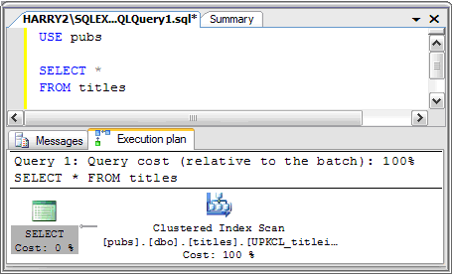

Above each graphical representation of the execution plan you will find the query header which displays the cost of that query relative to all other queries executed in the batch. The query header will also show you the query that was executed to generate the execution plan below it. The graphic portion of the execution plan is always read from right to left and from top to bottom. The number of branches leading into the top line of the execution plan increase based on the number of tables you include in your query. You get an idea of what the query optimizer did to get the result set just by looking at the execution plan.
If you just want to know how many rows and the estimated size per row as the query moves from step to step move your mouse pointer across the lines; you’ll then see a small yellow box with this info in it. Also, the lines are thicker when more rows are passed from one step to the next. So a thin line indicates 0 or few rows being passed. The thicker the line the more rows that are being passed to the next step and the slower the query will run. So one goal when developing a query is to get the number of rows it handles down to as few as possible as early as possible, preferably within the first or second step of the query. On the screen you can see that 18 rows with an estimated row size (total length per row) of 207 was passed from the first step to the second step.
To get more details on what happened and why so many or so few rows were pulled in a particular step you must move the mouse pointer on top of one of the icons. You will get a lot of information in a large yellow box. This gives you details as to what the query optimizer did to determine how many rows continue to the next step.
Yellow Box Explained
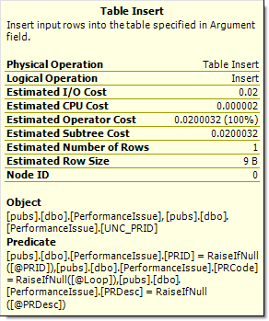 | Physical operation | This is the operator used by the query optimizer for this step. One example would be a nested loop.
 | Logical operation | Is usually the same as the physical operator. When different, this represents a keyword in the query. One example would be INNER JOIN.
 | Estimated I/O cost | This is the estimated cost for all I/O activity for a step. The lower this number is the better.
 | Estimated CPU Cost | This is the estimated cost for all CPU activity.
 | Estimated Operator Cost | Is the cost for the step being viewed. The lower this number is the better.
 | Estimated Subtree cost | Is the cost of the step being viewed and all previous steps.
 | Estimated Row count | This is the number of rows fetched by this step and passed to the next step.
 | Estimated row size | This is the estimated row size passed on to the next step.

Text-Based Execution Plans
If you do not have the ability to obtain a graphical execution plan, you can still use a series of Transact-SQL commands to retrieve an execution plan. While not as flashy for us visually orientated people, these Transact-SQL commands still provide a developer with a wealth of information to be used to find performance issues within a stored procedure or query.
SET SHOWPLAN_ALL - SET SHOWPLAN_ALL will instruct SQL Server not to execute Transact-SQL statements but return detailed information about how the statements will be executed and provides estimates of the resource requirements for the statements.
SET SHOWPLAN_ALL ON
GO
USE pubs
GO
SELECT * FROM authors
GO
